VPC Flow Logs

- VPC Flow Logs are a feature in AWS (Amazon web services) that enable you to capture information about the IP traffic flowing to and from network interfaces within your Virtual Private Cloud (VPC).
- VPC Flow Logs are a fundamental tool for network monitoring, security, and troubleshooting in cloud environments.
- A VPC Flow Log records metadata about the traffic flowing through your VPC. It doesn't capture the actual content of network packets but provides details such as:
- Source and destination IP addresses
- Ports
- Protocol
- Traffic acceptance or rejection
- Bytes sent/received
- Time of flow
- The logs/information are stored in Amazon CloudWatch Logs or Amazon S3 for further analysis.

Use cases:
- Network Monitoring and Troubleshooting
  - Identify traffic bottlenecks or failed connections.
  - Detect misconfigured security groups or network ACLs.
- Security Analysis
  - Detect abnormal or unauthorized traffic patterns.
  - Investigate potential malicious activities.
- Compliance and Auditing
  - Maintain records of network traffic for compliance.
  - Demonstrate security and operational controls.
- Cost Optimization
  - Monitor bandwidth usage and identify unnecessary traffic.

Key Features of VPC Flow Logs
Feature | Description
Traffic Capture | Captures inbound and outbound traffic at the ENI (Elastic Network Interface) level.
Filtering | You can include or exclude specific traffic based on conditions.
Aggregation Interval | Logs are aggregated over intervals (e.g., 1-minute or 10-minute periods).
Log Destination | Logs can be sent to Amazon CloudWatch Logs or Amazon S3.
Custom Log Format | Customize the fields you want in each log record.
Data Plane Integration | Provides deep visibility into VPC-level network activity.
Support for All Interfaces | Works on EC2, NAT Gateways, Load Balancers, Transit Gateways, etc.

Now let’s work with the VPC flow logs practically.
Procedure: Create a VPC with a single subnet, and create an instance within the subnet, then now collect/catch the all the traffic information to and from, within the VPC. Store all these information in the Cloud Watch.

Block Diagram:
AWS Cloud Environment
Cached traffic info
VPC-01
Log Group
Cloud Watch-01
Instance-01-01
Subnet-01-01

Now perform above block diagram content in practically, by creating same infrastructure practically.

Step1: Create VPC with single subnet, by configuring IGW, RT and SG.
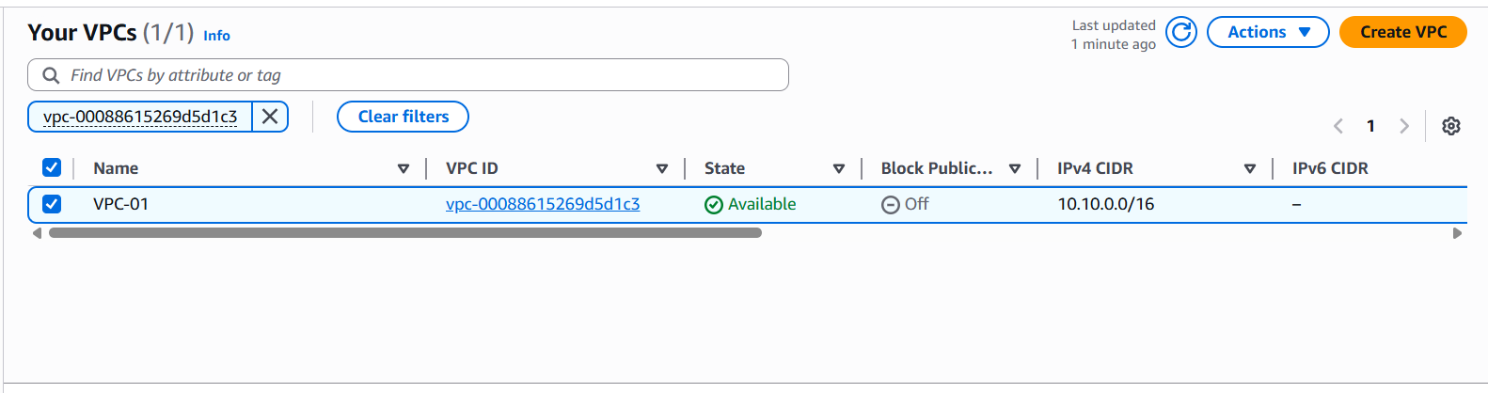
Fig: VPC-01
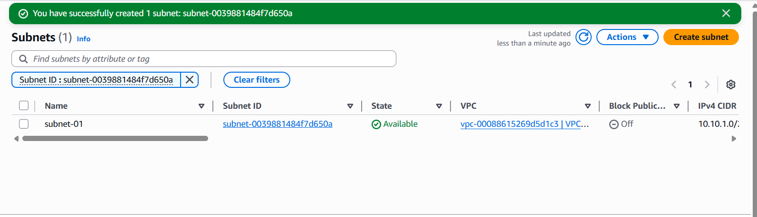
Fig: Subnet-01

Route Table: Write rule to Route traffic using IGW
SG: Allow Inbound all IP4 traffic.

Step2: Create the EC2 instance (Instance-01) within the subnet-01.
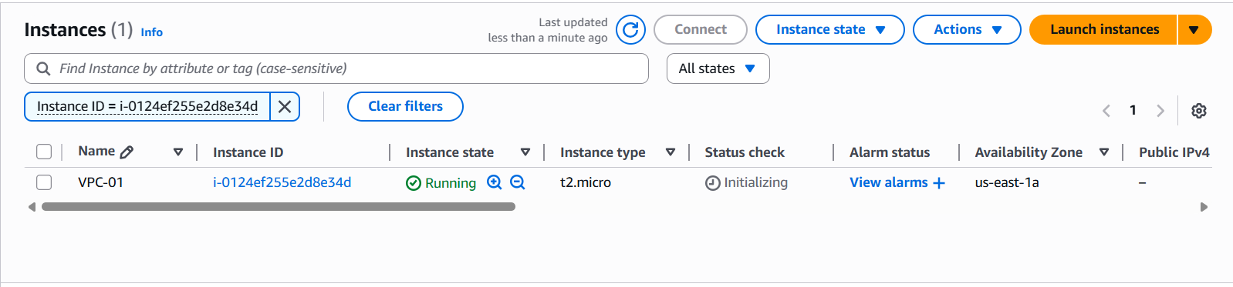
Fig: Instance-01 is created.

Step3: Create a Log Group in cloud watch to store the collected IP traffic information.

Go To Cloud Watch (global search)LogsLog GroupCreate log group.
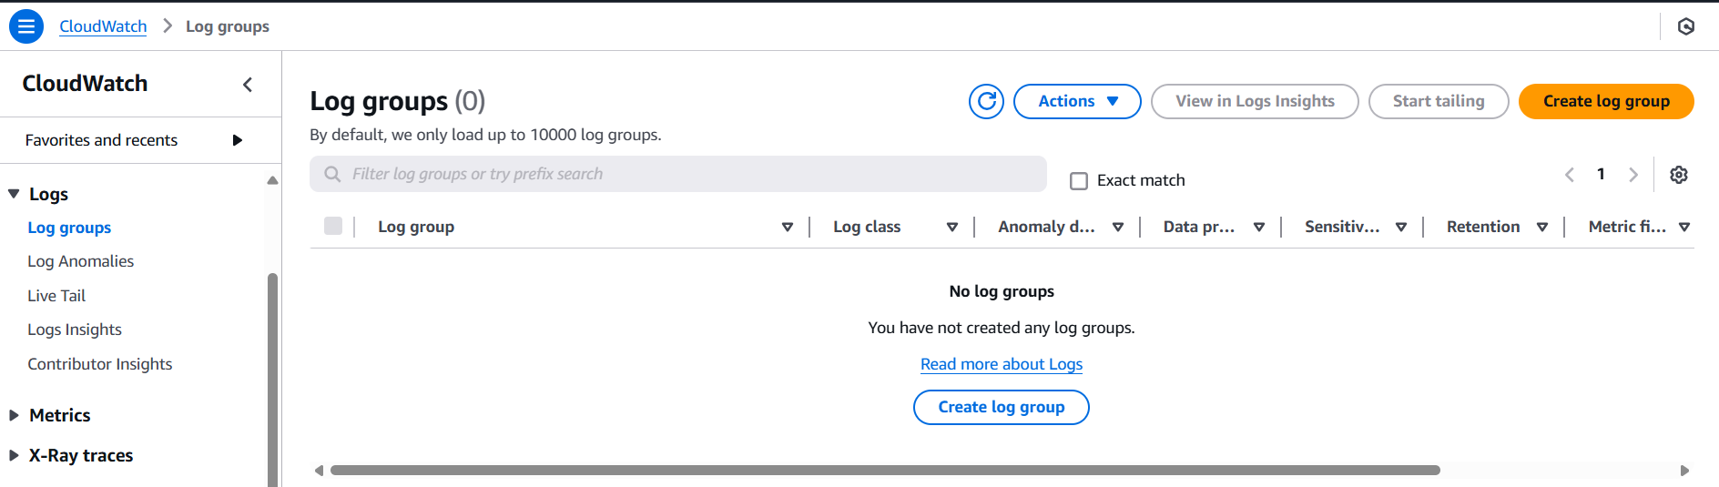

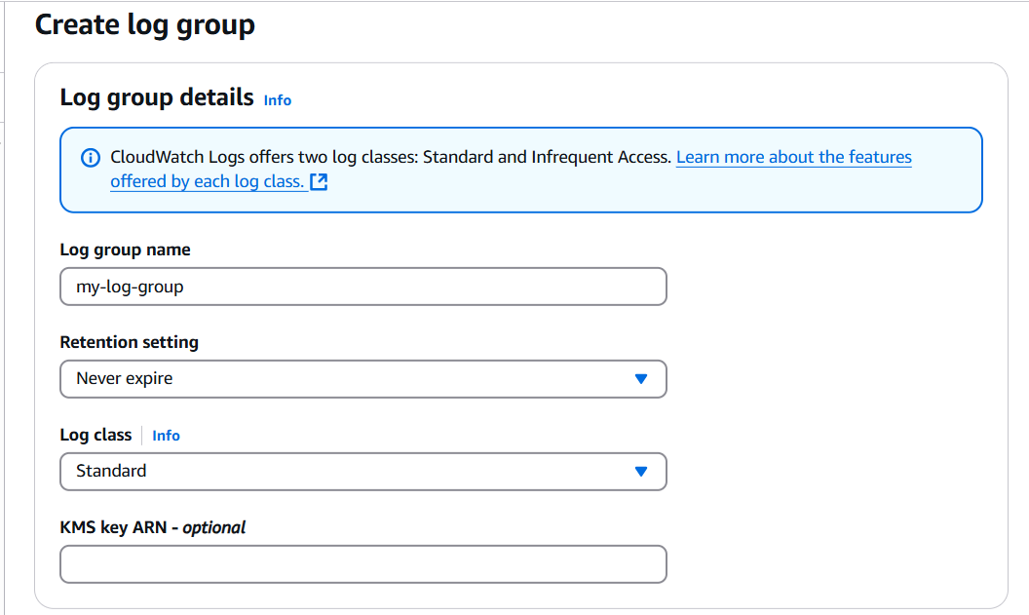
Fig: Configuring the log group.

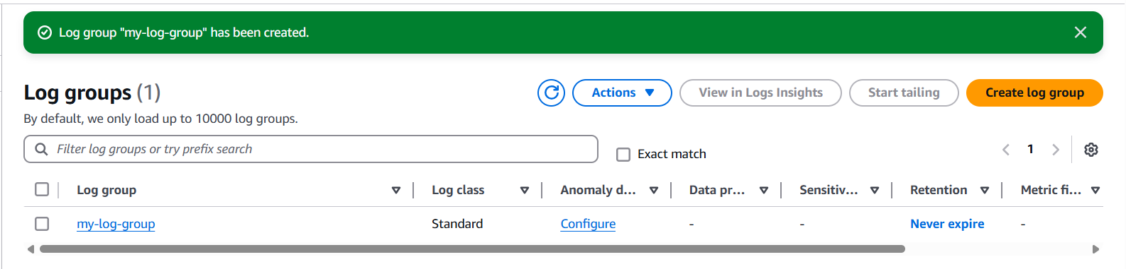
Fig: Log group is created (my-log-group).

Note:
In order to collect the information about the traffic which is flowing to and from of the VPC in the cloud watch logs group, first we need to create the IAM role by attaching stable policies to the role.
Then this IAM role should be attached to the VPC flow log while creating it. Then only we can collect the information/data about the flow of traffic to and from the VPC.

Step4: Create an IAM role and for this role attach a suitable policy, in order to collect traffic info in cloud watch.
Role Creation: Go ToIAMRolecreate rolecustom trust policyNextNextRole nameCreate role.
{
"Version": "2012-10-17",
"Statement": [
{
"Effect": "Allow",
"Principal": {
"Service": "vpc-flow-logs.amazonaws.com"
},
"Action": "sts:AssumeRole"
}
]
}

Fig: Custom trust policy to allow flow logs service.

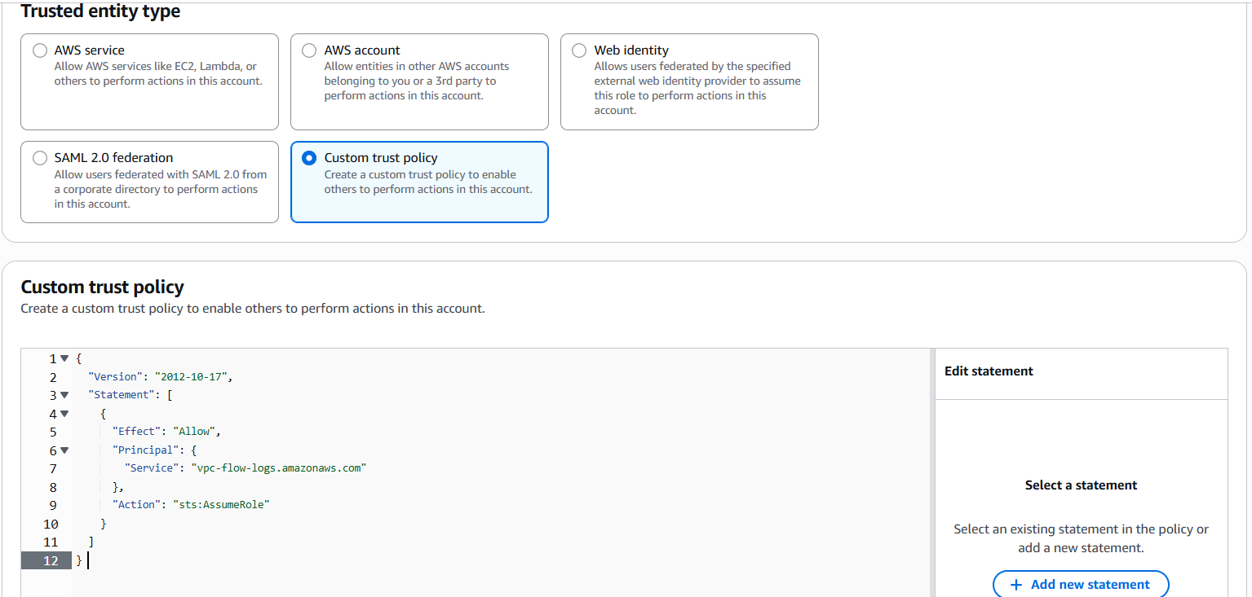
Fig: Custom trust policy is uploaded.
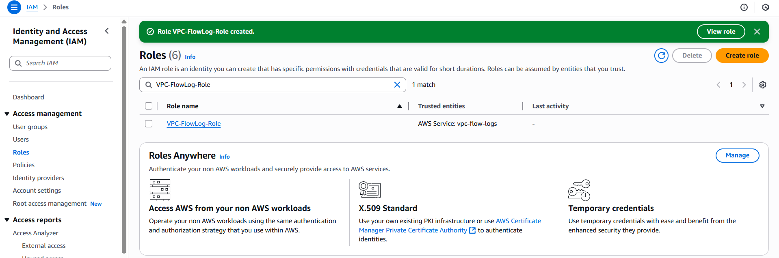
Fig: Role is created successfully.

Policy Creation: Go ToIAMPoliciesCreate policyJSONNextPolicy nameCreate a policy.
{
"Version": "2012-10-17",
"Statement": [
{
"Effect": "Allow",
"Action": [
"logs:CreateLogGroup",
"logs:CreateLogStream",
"logs:PutLogEvents",
"logs:DescribeLogGroups",
"logs:DescribeLogStreams"
],
"Resource": "*"
}
]
}

Fig: IAM Policy to allow Flow logs.
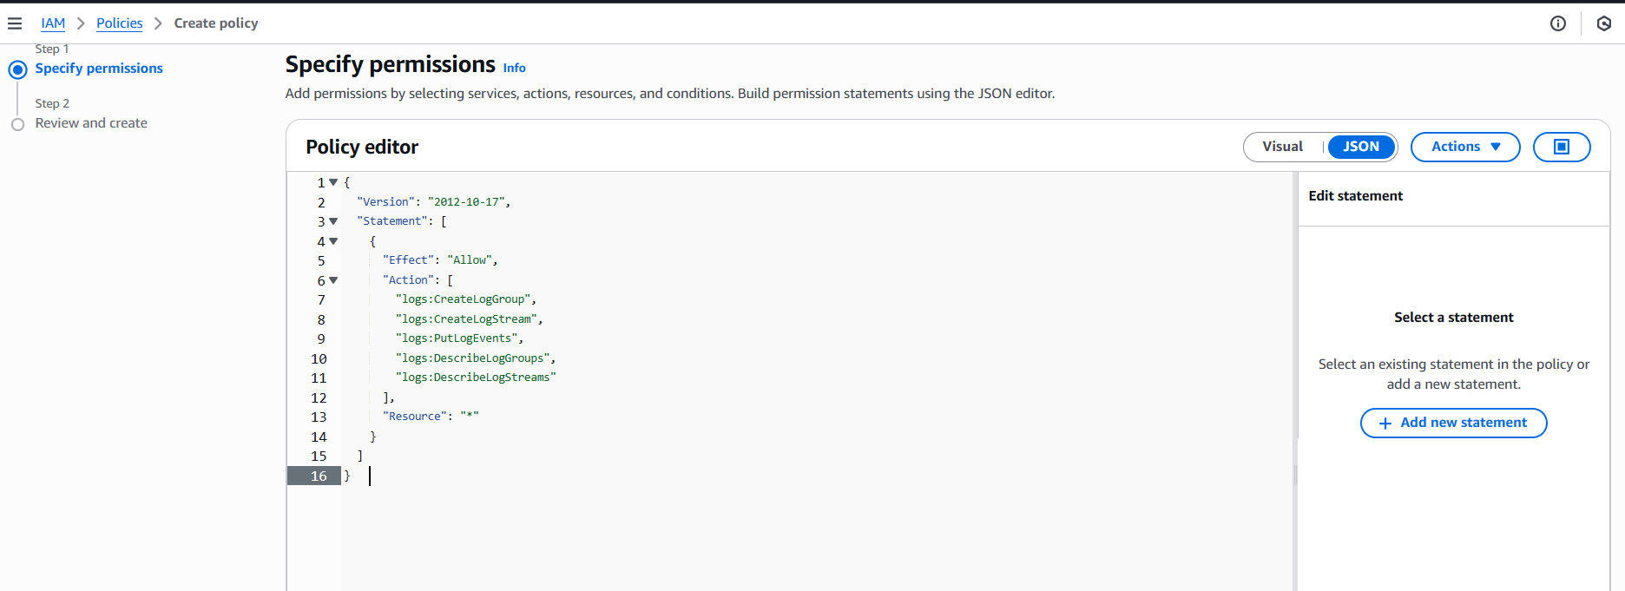
Fig: IAM policy is uploaded.

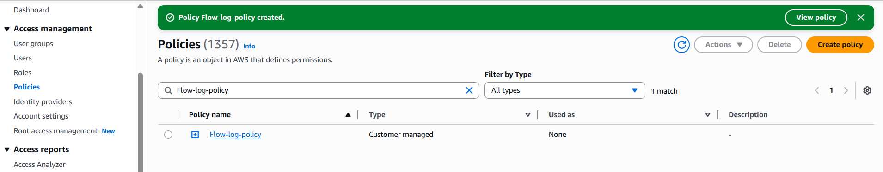
Fig: IAM Policy is created.

Step5: Now attach IAM policy (Flow-log-policy) to the IAM Role (VPC-FlowLog-Role).
Go ToIAM RoleSelect created Role (VPC-FlowLog-Role)Add permissionsAttach policySelect policy and attach it.

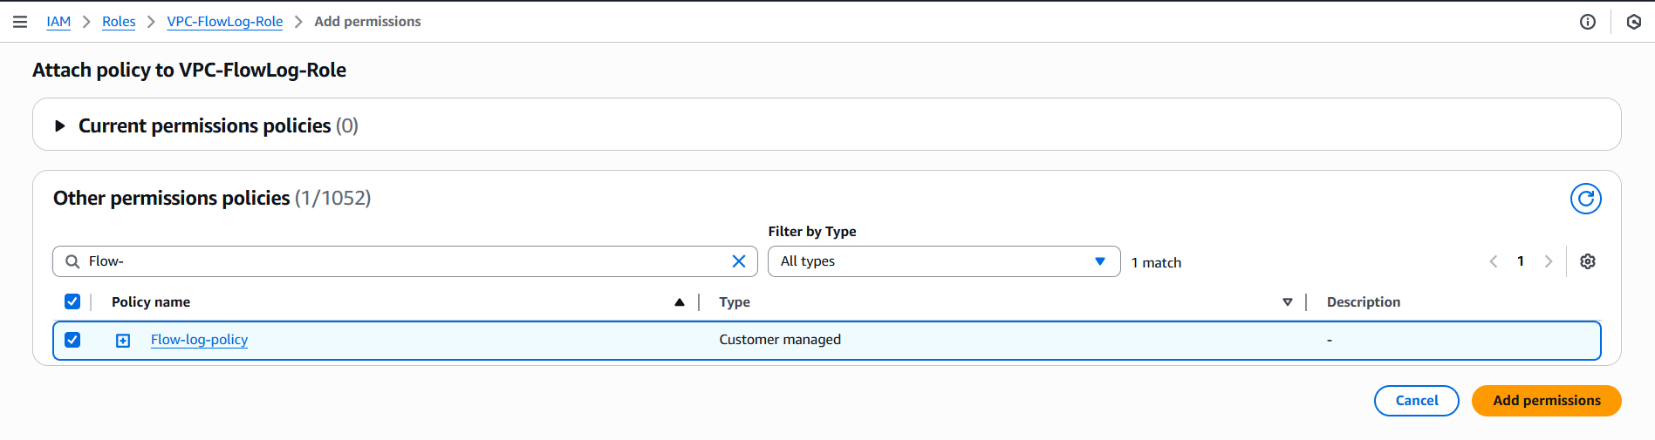
Fig: Adding policy to the Role.

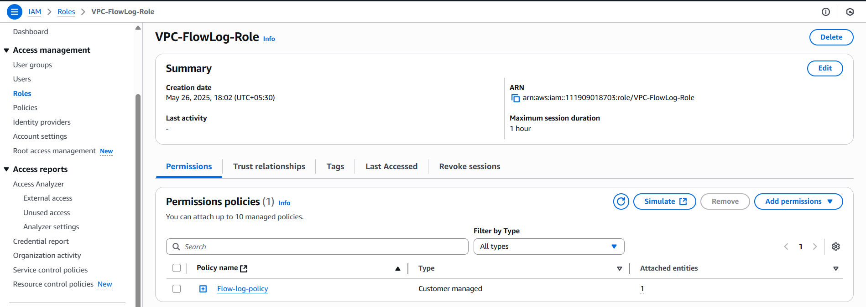
Fig: Policy is attached to the Role successfully.

Step6: Then attach this Role (VPC-FlowLog-Role) while creation the VPC Flow Logs.

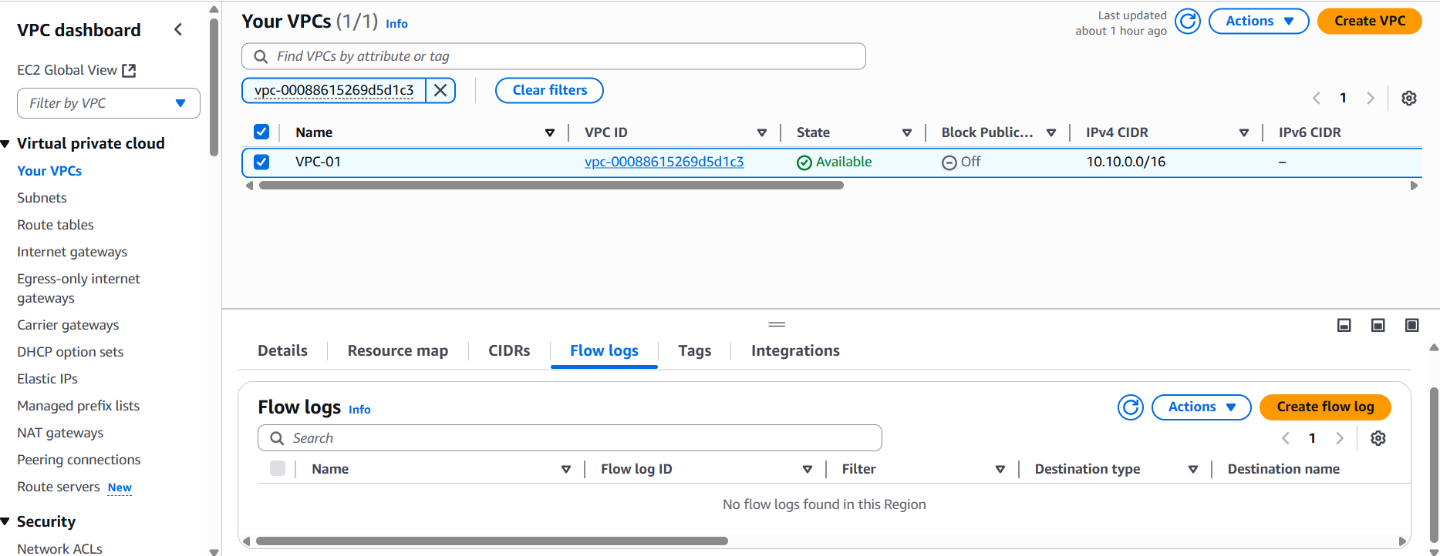

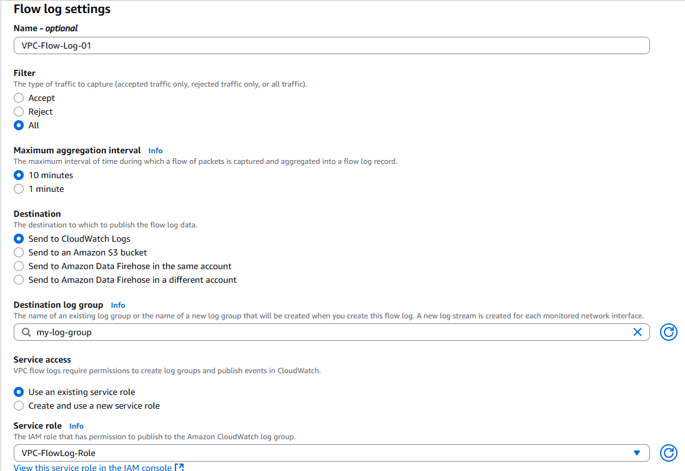
Fig: Configuring of Flow Logs.

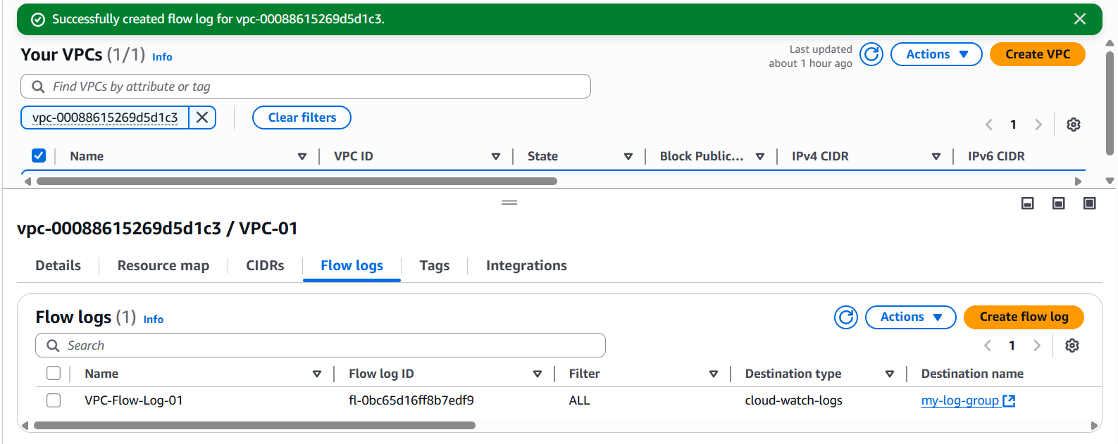
Fig: Flow Log (VPC-Flow-Log-01) is created successfully.
Now just connect to instances and do some activities like installing nginx, or ping to any IP or google and so on. After waiting 10 to 30 secs a Log steam is generated. It consists of traffic information which flow in and out of VPC.
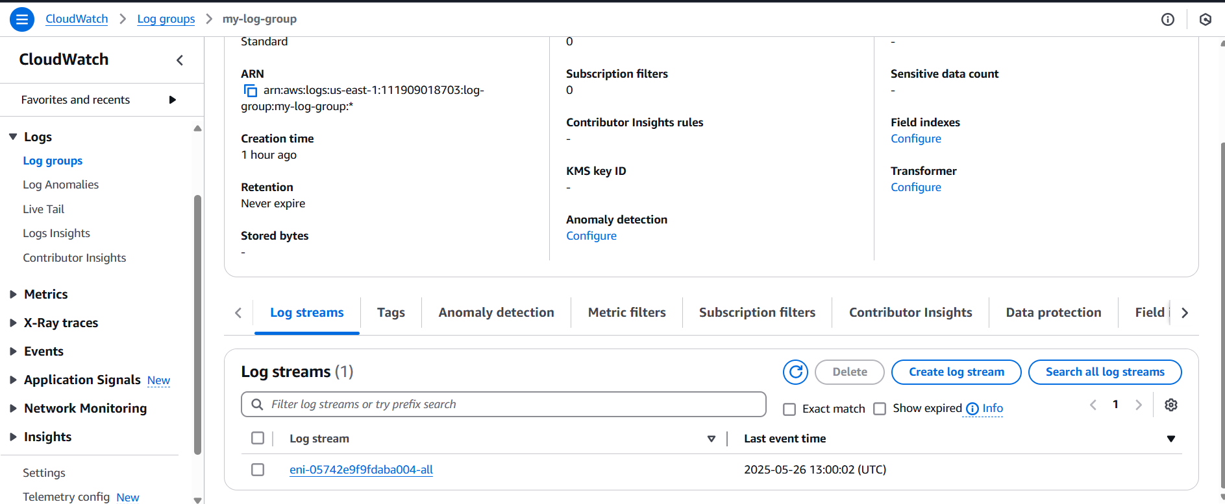
Fig: Log steam is generated.
NIC ID

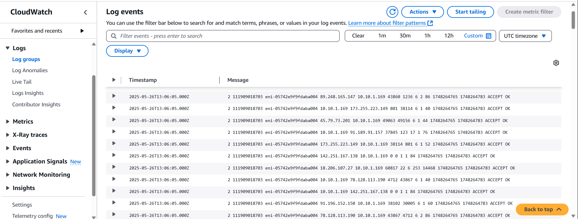
Fig: Information about the traffic which is flowing to and from of the VPC network.

